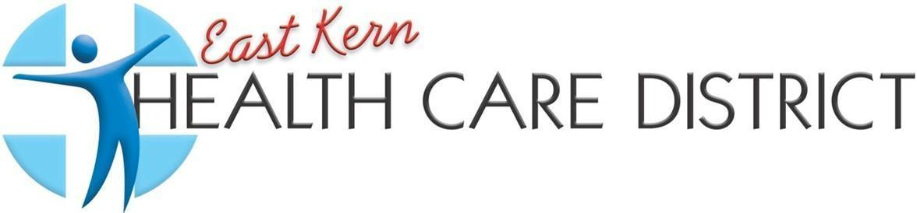
REGULAR MEETING AGENDA
EAST KERN HEALTH CARE DISTRICT
BOARD OF DIRECTORS
5:30PM March 3rd, 2026
(In Person and Zoom)

9300 N Loop Blvd, California City, CA 93505
MISSION STATEMENT: “Building health, well-being, and resiliency”
PLEASE CLICK THE LINK BELOW TO JOIN THE MEETING:
https://us02web.zoom.us/j/86179921607?pwd=abYL7DLkRFaxwDDUJu7z8d3PaoSPnE.1
OR TELEPHONE: US: +1 669 900 6833
ZOOM ID: 86179921607
PASSCODE: 120485

- OPEN MEETING
- PLEDGE OF ALLEGIANCE/INVOCATION
- ROLL CALL AND CALL TO ORDER
Per the Grand Jury Report Dated April 29, 2024. R4 under Recommendations, states, …” Follow Robert’s Rules of Order, eliminate cell phone usage, and reduce side bar conversation during the meeting…”
- APPROVAL OF AGENDA
Board members can amend the agenda, in compliance with the Brown Act, before or after someone makes a motion to adopt the agenda. To do this, any board member can motion to add emergency items, delete items, or change things around. Once someone motions to amend the agenda, the board takes a vote, and the majority rules. The meeting will proceed according to the approved agenda.
- Presentation “KTS Farmers Market” Quesha Bernard
- NEW BUSINESS
  - Eva Hebebrand “Current Year Budget Review for Next Years Budget 2026-2027”
  - Vendor Payments (INFORMATION ONLY)
  - Resolution 10-3.002 Conflict Of Interest
  - Review of Contracts with Joselito Lacson
  - Directors Onboarding Packet
- PUBLIC COMMENTS
Members of the public are welcome to address the Board on any matter NOT on the agenda and over which the Board has authority. If you wish to speak, please state your name for the record and limit your comments to 1 minute.
- COMMUNITY ANNOUNCEMENTS
- CONTINUED BUSINESS
  - Revised Employee Handbook
  - Budget Discussion
- STAFF REPORT
  - Rubi Rizo
VIII. CLOSED SESSION
a. Conference with Real Property Negotiations (§ 54956.8)
Property: Ridgecrest Regional Hospital
Agency Negotiator: Alex Lemieux
Negotiating Parties: Ridgecrest Regional Hospital
Under Negotiations: Price and other terms
IX. REPORT OUT OF CLOSED SESSION
X. CONSENT CALENDAR
All items on the Consent Calendar are considered routine, non-controversial, and will be approved by one (1) motion if no member of the Board, Staff, or Public wishes to comment or ask questions. Public comment to be limited to one (1) minute. Roll Call votes are required.

- APPROVAL OF MINUTES
- Regular Meeting: February 17th, 2026
XI. CLOSE MEETING
A. PRESIDENTS COMMENTS
B. DIRECTORS COMMENTS – AB 1234
C. DIRECTOR REPORTS
D. FUTURE AGENDA ITEMS –
- Kern County Multi-Jurisdictional Hazard Mitigation Plan (MJHMP)
- R. Rizo presenting SEP plan for MJHMP
- Administrative Code Review
E. ADJOURNMENT

Next Regular Meeting: Tuesday, March 17th , 2026, at 5:30 p.m. In person and (ZOOM) 9300 N Loop Blvd., California City, CA 93505
“Pursuant to Government Code section 54952(a), any request for a disability-related modification or accommodation, including auxiliary aids or services, that is sought in order to participate in this agendized public meeting should be directed to the District’s office at (760) 373-2804 at least 48 hours prior to said meeting”

