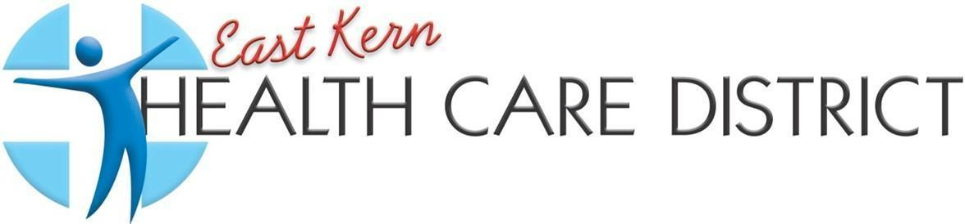
REGULAR MEETING AGENDA
EAST KERN HEALTH CARE DISTRICT
BOARD OF DIRECTORS
5 p.m. February 17th, 2026
(In Person and Zoom)

9300 N Loop Blvd, California City, CA 93505
MISSION STATEMENT: “Building health, well-being, and resiliency”
PLEASE CLICK THE LINK BELOW TO JOIN THE MEETING:
https://us02web.zoom.us/j/86179921607?pwd=abYL7DLkRFaxwDDUJu7z8d3PaoSPnE.1
OR TELEPHONE: US: +1 669 900 6833
ZOOM ID: 86179921607
PASSCODE: 120485

- OPEN MEETING
- PLEDGE OF ALLEGIANCE/INVOCATION
- ROLL CALL AND CALL TO ORDER
Per the Grand Jury Report Dated April 29, 2024. R4 under Recommendations, states, …” Follow Robert’s Rules of Order, eliminate cell phone usage, and reduce side bar conversation during the meeting…”
- APPROVAL OF AGENDA
Board members can amend the agenda, in compliance with the Brown Act, before or after someone makes a motion to adopt the agenda. To do this, any board member can motion to add emergency items, delete items, or change things around. Once someone motions to amend the agenda, the board takes a vote, and the majority rules. The meeting will proceed according to the approved agenda.
- NEW BUSINESS
a. Presentation by Emily Garcia “My Diabetes Tutor”
b. Eva Hebebrand (Financials)
1.Balance Sheet unaudited December 2025 - January 2026
2.Profit and Loss unaudited December 2025 - January 2026
3.Check detail December 2025 – January 2026
4.Form 941 4th quarter
c. Vendor Payments (INFORMATION ONLY)
- PUBLIC COMMENTS
Members of the public are welcome to address the Board on any matter NOT on the agenda and over which the Board has authority. If you wish to speak, please state your name for the record and limit your comments to 1 minute.
- COMMUNITY ANNOUNCEMENTS
- Staff Report
  - Rubi Rizo
- CONTINUED BUSINESS
  - Resolution 2-1.402 (a) Start meeting time adjustment to 5:30 PM
  - Revised Employee Handbook
  - Employee Onboarding Packet
  - Payroll Online Process
  - Budget Discussion
III. CLOSED SESSION
a. Contract negotiations for Assistant Office Manager
IV. REPORT OUT OF CLOSED SESSION
IX. CONSENT CALENDAR
All items on the Consent Calendar are considered routine, non-controversial, and will be approved by one (1) motion if no member of the Board, Staff, or Public wishes to comment or ask questions. Public comment to be limited to one (1) minute. Roll Call vote is required.

- APPROVAL OF MINUTES
- Regular Meeting: February 3rd, 2026
XI. CLOSE MEETING
A. PRESIDENTS COMMENTS
B. DIRECTORS COMMENTS – AB 1234
C. DIRECTOR REPORTS
D. FUTURE AGENDA ITEMS –
- Kern County Multi-Jurisdictional Hazard Mitigation Plan (MJHMP)
- Conferences
- R. Rizo presenting SEP plan for MJHMP
- Resolution 10-3.002 Conflict of Interest
E. ADJOURNMENT

Next Regular Meeting: Tuesday, March 3rd, 2026, at 5 p.m. In person and (ZOOM) 9300 N Loop Blvd., California City, CA 93505
“Pursuant to Government Code section 54952(a), any request for a disability-related modification or accommodation, including auxiliary aids or services, that is sought in order to participate in this agendized public meeting should be directed to the District’s office at (760) 373-2804 at least 48 hours prior to said meeting”

